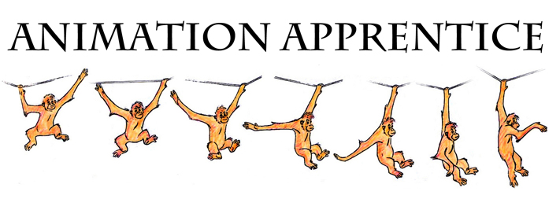
Non-Disclosure & Confidentiality Agreement

This agreement is between Animation Apprentice and

………………………………… (“The Student”).

Background

During the course of study with the online Animation Apprentice training course, Animation Apprentice wishes to deliver to The Student various documents, videos, drawings, and other Proprietary materials (“The Course Materials”) of a highly sensitive and confidential nature, and further wishes that the Student shall maintain at all times the confidentiality of The Course Materials.

In consideration of the benefits to both parties, Animation Apprentice and The Student hereby agree as follows:

- The Course Materials are made available for The Student’s personal use and are not to be shared with any third party, whether for sale or as a gift. In particular, the Student agrees not to upload or distribute the Course Materials to any website or blog under any circumstances.
- The Course Materials are individually protected with a unique watermark so that any violation of the terms of this agreement can be traced to the party in breach.
- The Course Materials shall remain the property of Animation Apprentice at all times.
- All work completed by The Student on The Course shall be owned by The Student, but Animation Apprentice shall have a license to use such work on the course website, or for promotion of the course.
- Any breach by The Student under this Agreement will result in irreparable inquiry to Animation Apprentice for which damages and other legal remedies will be inadequate. In seeking enforcement of any of these obligations, Animation Apprentice will be entitled (in addition to other remedies) to preliminary and permanent injunctive and other equitable relief to prevent, discontinue and/or restrain the breach of this Agreement.
- This Agreement shall be binding upon and will inure to the benefit of the parties hereto and their respective successors and assigns.
- This Agreement is governed by and will be construed in accordance with the laws of England, and the courts of England shall be the exclusive forum.
- This Agreement takes precedence over any prior written or oral agreement between Animation Apprentice and The Student.
- This Agreement may not be modified, in whole or in part, except by an agreement in writing signed by both parties.

IN WITNESS WHEREOF, the parties have executed this Agreement as of the date below.

For Animation Apprentice

By: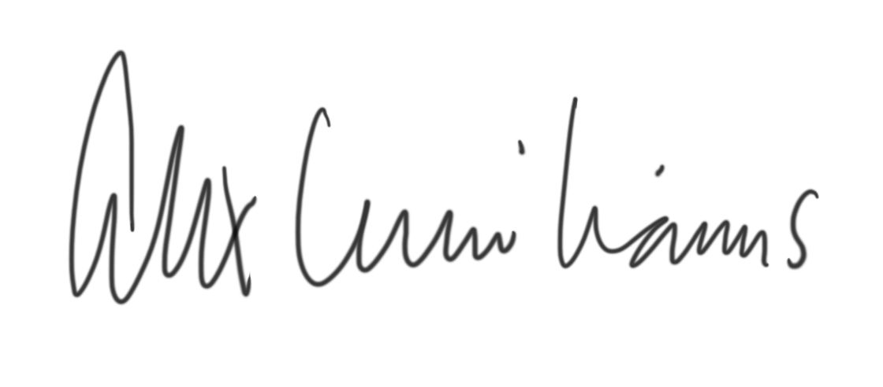
Signature

Alexander Williams

The Student

By: ______________________
Signature

______________________
Printed Name

Date:

